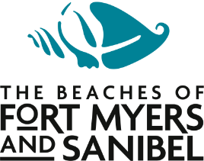
NEWS RELEASE

June 17, 2020
FOR IMMEDIATE RELEASE
CONTACT: Francesca Donlan, Jackie Parker 239-338-3500

New podcast celebrates The Beaches of Fort Myers & Sanibel

LEE COUNTY, Fla. – The Beaches of Fort Myers & Sanibel introduces Shellcast, the podcast designed to bring a slice of Southwest Florida to people all over the world.

Shellcast, the podcast of The Beaches of Fort Myers & Sanibel, is set to launch June 23, giving listeners a chance to soak up some virtual sun and hear what makes Southwest Florida so special.

“I’m a big fan of podcasts and can’t wait for everyone to give Shellcast a listen,” said Tamara Pigott, executive director of the Lee County Visitor & Convention Bureau (VCB). “By downloading the podcast, listeners anywhere in the world can enjoy the sounds of our beaches, nature and interviews with locals.”

The first three Shellcast episodes include an interview with Capt. Brian Holaway of Captain Brian on the Water; a visit to the 2020 Burrowing Owl Festival and interviews with Cape Coral Friends of Wildlife members; and a walk on a Sanibel beach with Dorrie Hipschman, executive director of The Bailey-Matthews National Shell Museum.

The 2020 Infinite Dial Study shows among the U.S. population ages 12 and older, over 104 million (37%) people are listening to podcasts regularly, up from 32% in 2019.

Shellcast is a collaborative effort with host and producer Jackie Parker, VCB communications manager.

Shellcast will be available on fortmyers-sanibel.com, Apple Podcasts, Spotify, iHeartRadio and wherever fine podcasts are downloaded.

-30-

