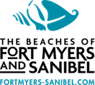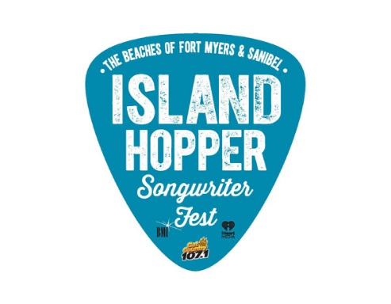
MEDIA ALERT

July 27, 2020
FOR IMMEDIATE RELEASE
Contacts: Jackie Parker 239-338-3500

Island Hopper Songwriter Fest Postponed
LEE COUNTY, Fla. – The Beaches of Fort Myers & Sanibel, iHeartMedia and BMI announced today that they have postponed the 7th annual Island Hopper Songwriter Fest.

“After extensive consideration, and in light of the COVID-19 virus, we felt this was the most prudent way to proceed,” said Tamara Pigott, executive director for The Beaches of Fort Myers & Sanibel. “We are just as disappointed as our songwriters and fans but we’re looking forward to next year.”
The new dates will be Sept. 17-26, 2021.
Island Hopper Songwriter Fest is a 10-day music festival in Southwest Florida. It draws some of country music’s greatest singer-songwriters from Nashville and nationwide. More than 80 artists perform more than 100 shows, most of which are free and in small, intimate venues across Captiva Island, Fort Myers Beach and downtown Fort Myers.
“iHeart is actively working with Lee County and BMI to create new virtual fan experiences for our growing Island Hopper audience as well as keeping an eye on making 2021 our best festival ever,” said Louis Kaplan, senior vice president of programming.
Island Hopper Songwriter Fest organizers have produced three monthly Songs from the Sofa – a virtual experience featuring previous Island Hopper songwriters on Instagram Live. Songs from the Sofa will continue on the third Thursday of every month. Updates will be shared on https://www.island-hopper.fortmyers-sanibel.com/

The annual Island Hopper Songwriter Fest is proudly produced by the Lee County Visitor & Convention Bureau, BMI, iHeartMedia and Cat Country 107.1.

-30-

Island Hopper is produced by the Lee County Visitor & Convention Bureau, iHeartMedia,
Cat Country 107.1 and BMI, the largest music rights organization in the U.S. Visit IslandHopperFest.com or access the media tool kit. Follow the festival hashtag #islandhopperfest as well as the event’s Twitter, Instagram and Facebook feeds.

